What is a Life Purpose?

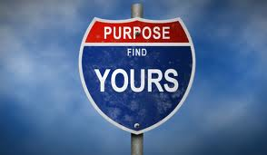

A Life Purpose is a unique and specific reason you are here on this earth,
a guide for your Being and Doing, “custom-fitted” to you,
your personality, values, and Unique inborn Gifts.

What is a “Power Purpose?”

A Power Purpose is your Life Purpose, the unique reason you are here on this earth,
experienced at such a clear, deep, committed level it fulfills 6 desired intentions:

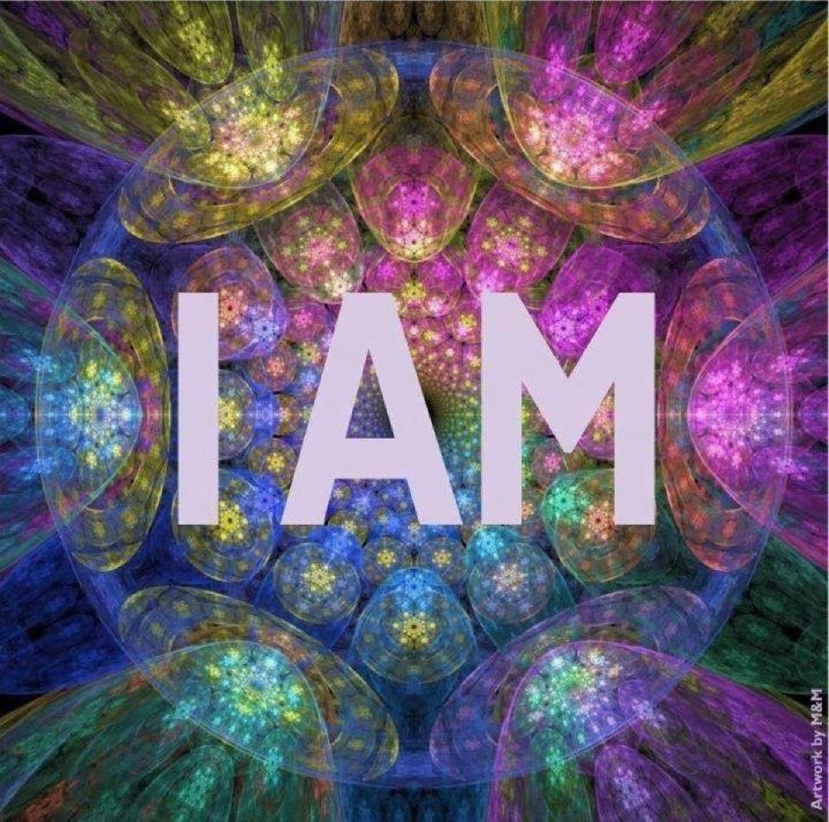

You are prompted to BE and DO something positive. (Possibly a “calling” within you.)

You DO work that you LOVE and you are GOOD AT IT.

You feel incredibly Fulfilled, Satisfied, Happy – having Fun!

You and your gifts respond to and provide what the World needs.

You AND the “recipients” of your gifts, are BOTH PROSPERED AND BENEFITTED.

You make a Valuable Difference in the World, advancing good (e.g., peace; people have loving interactions; people live with higher awareness and consciousness, etc.)

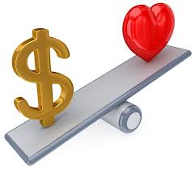

© Your Dream Stream 2013 All Rights Reserved

